""" Python3 program to solve N Queen Problem
using Branch or Bound """

N = 8

""" A utility function to print solution """
def printSolution(board):
for i in range(N):
for j in range(N):
print(board[i][j], end = " ")
print()

""" A Optimized function to check if
a queen can be placed on board[row][col] """
def isSafe(row, col, slashCode, backslashCode,
rowLookup, slashCodeLookup,
backslashCodeLookup):
if (slashCodeLookup[slashCode[row][col]] or
backslashCodeLookup[backslashCode[row][col]] or
rowLookup[row]):
return False
return True

""" A recursive utility function
to solve N Queen problem """
def solveNQueensUtil(board, col, slashCode, backslashCode,
rowLookup, slashCodeLookup,
backslashCodeLookup):

""" base case: If all queens are
placed then return True """
if(col >= N):
return True
for i in range(N):
if(isSafe(i, col, slashCode, backslashCode,
rowLookup, slashCodeLookup,
backslashCodeLookup)):

""" Place this queen in board[i][col] """
board[i][col] = 1
rowLookup[i] = True
slashCodeLookup[slashCode[i][col]] = True
backslashCodeLookup[backslashCode[i][col]] = True

""" recur to place rest of the queens """
if(solveNQueensUtil(board, col + 1,
slashCode, backslashCode,
rowLookup, slashCodeLookup,
backslashCodeLookup)):
return True

""" If placing queen in board[i][col]
doesn't lead to a solution,then backtrack """

""" Remove queen from board[i][col] """
board[i][col] = 0
rowLookup[i] = False
slashCodeLookup[slashCode[i][col]] = False
backslashCodeLookup[backslashCode[i][col]] = False

""" If queen can not be place in any row in
this column col then return False """
return False

""" This function solves the N Queen problem using
Branch or Bound. It mainly uses solveNQueensUtil()to
solve the problem. It returns False if queens
cannot be placed,otherwise return True or
prints placement of queens in the form of 1s.
Please note that there may be more than one
solutions,this function prints one of the
feasible solutions."""
def solveNQueens():
board = [[0 for i in range(N)]
for j in range(N)]

# helper matrices
slashCode = [[0 for i in range(N)]
for j in range(N)]
backslashCode = [[0 for i in range(N)]
for j in range(N)]

# arrays to tell us which rows are occupied
rowLookup = [False] * N

# keep two arrays to tell us
# which diagonals are occupied
x = 2 * N - 1
slashCodeLookup = [False] * x
backslashCodeLookup = [False] * x

# initialize helper matrices
for rr in range(N):
for cc in range(N):
slashCode[rr][cc] = rr + cc
backslashCode[rr][cc] = rr - cc + 7

if(solveNQueensUtil(board, 0, slashCode, backslashCode,
rowLookup, slashCodeLookup,
backslashCodeLookup) == False):
print("Solution does not exist")
return False

# solution found
printSolution(board)
return True

""" Python3 program to solve N Queen Problem using backtracking """
B= 4

""" ld is an array where its indices indicate row-col+N-1
(N-1) is for shifting the difference to store negative
indices """
ld = [0] * 30

""" rd is an array where its indices indicate row+col
and used to check whether a queen can be placed on
right diagonal or not"""
rd = [0] * 30

"""column array where its indices indicates column and
used to check whether a queen can be placed in that
row or not"""
cl = [0] * 30

""" A utility function to print solution """
def printSolutionB(board):
for i in range(B):
for j in range(B):
print(board[i][j], end = " ")
print()

""" A recursive utility function to solve N
Queen problem """
def solveNQUtilB(board, col):

""" base case: If all queens are placed
then return True """
if (col >= B):
return True

""" Consider this column and try placing
this queen in all rows one by one """
for i in range(B):

""" Check if the queen can be placed on board[i][col] """
""" A check if a queen can be placed on board[row][col].
We just need to check ld[row-col+n-1] and rd[row+coln]
where ld and rd are for left and right diagonal respectively"""
if ((ld[i - col + B - 1] != 1 and
rd[i + col] != 1) and cl[i] != 1):

""" Place this queen in board[i][col] """
board[i][col] = 1
ld[i - col + B - 1] = rd[i + col] = cl[i] = 1

""" recur to place rest of the queens """
if (solveNQUtilB(board, col + 1)):
return True

""" If placing queen in board[i][col]
doesn't lead to a solution,
then remove queen from board[i][col] """
board[i][col] = 0 # BACKTRACK
ld[i - col + B - 1] = rd[i + col] = cl[i] = 0

""" If the queen cannot be placed in
any row in this column col then return False """
return False

""" This function solves the N Queen problem using
Backtracking. It mainly uses solveNQUtil() to
solve the problem. It returns False if queens
cannot be placed, otherwise, return True and
prints placement of queens in the form of 1s.
Please note that there may be more than one
solutions, this function prints one of the
feasible solutions."""
def solveNQB():
board = [[0, 0, 0, 0],
[0, 0, 0, 0],
[0, 0, 0, 0],
[0, 0, 0, 0]]
if (solveNQUtilB(board, 0) == False):
printf("Solution does not exist")
return False
printSolutionB(board)
return True

# Driver Code

flag=1
while flag==1:
print("1. solve N Queen Problem using Branch or Bound \n 2. Queen Problem using backtracking \n 3. Exit\n")
ch=int(input("Enter your Choice (from 1 to 3) :"))
if ch==1:
print("solution of N Queen Problem using Branch or Bound")
solveNQueens() # function calling
a = input("Do you want to continue (y/n) :")
if a == "y":
flag = 1
else:
flag = 0
print("Thanks for using this program!")
elif ch==2:
print("solution of Queen Problem using backtracking")
solveNQB()
a = input("Do you want to continue (y/n) :")
if a == "y":
flag = 1
else:
flag = 0
print("Thanks for using this program!")

elif ch==3:
flag=0
print("Thanks for using this program!")
else:
print("!!Wrong Choice!! ")
a=input("Do you want to continue (y/n) :")
if a=="y":
flag=1
else:
flag=0
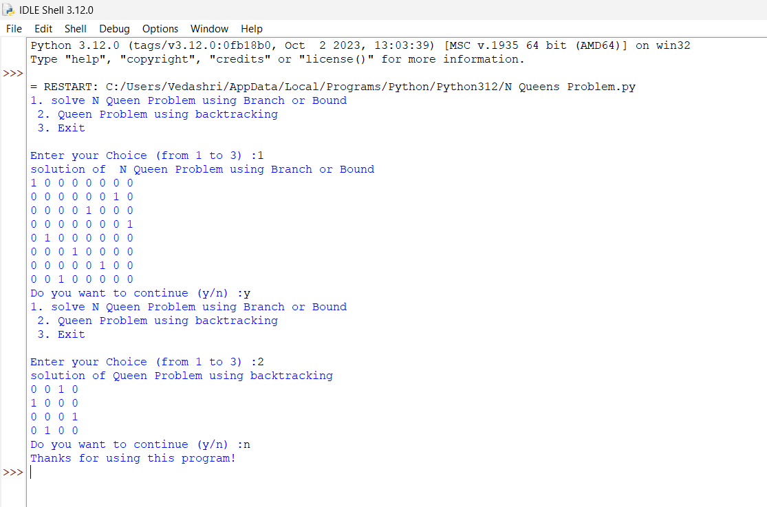
print("Thanks for using this program!")

